Select “Create a new project” from launch dialogue (or File > New > Project)

Search for ‘MVC’ and select **ASP.NET Web Applications (.NET Framework)**

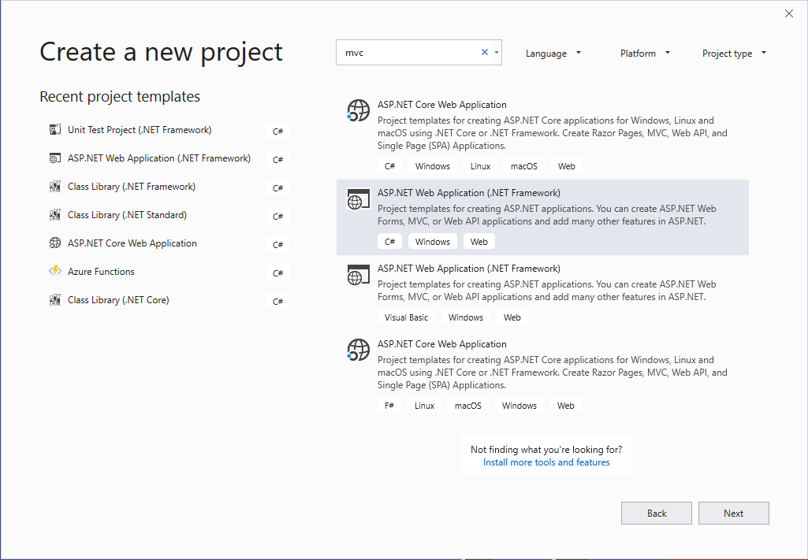

Hit Next

Fill out Project and solution name.

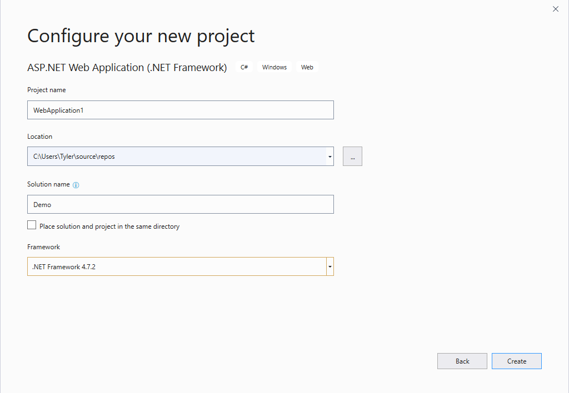

Hit Create

Select MVC

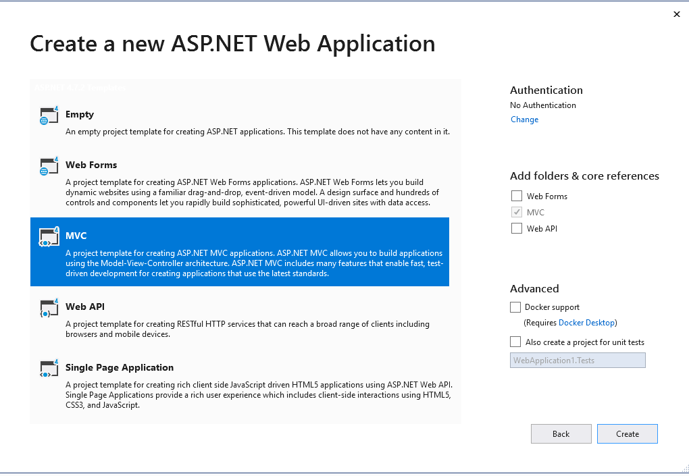

Default Directory

